Task 1
Select distinct (unique) elements of the amount column from the book table.
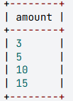
Task2
Calculate the number of distinct books and the number of book copies for each author stored in the warehouse. Name the columns Author, Distinct_books, and Number_of_copies respectively.
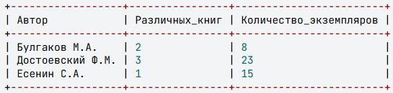
Task3
Display the author's last name and initials, as well as the minimum, maximum, and average price of books for each author. Name the calculated columns Minimum_price, Maximum_price, and Average_price, respectively.
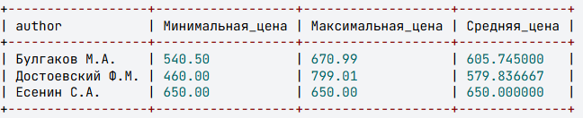
Task4
For each author, calculate the total cost of books S (column name: Cost), as well as the value-added tax (column name: VAT) included in this amount at a rate of 18% (k=18), and the cost of the books without it (Cost_without_VAT). Round the values to two decimal places. Use the following formulas to calculate the VAT (tax) and Cost without VAT (S_without_tax) in the query:
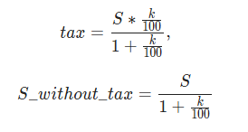
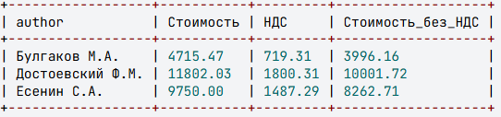
Task5
Display the price of the cheapest book, the price of the most expensive book, and the average price of all books in the warehouse. Name the columns Minimum_price, Maximum_price, and Average_price respectively. Round the average price to two decimal places.
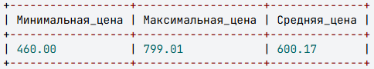

Task6
Calculate the average price and total cost of books whose number of copies falls within the range of 5 to 14, inclusive. Name the columns Average_price and Cost respectively, and round the values to two decimal places.
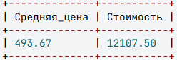
Task7
Calculate the total cost of all copies for each author, excluding the books "Идиот" and "Белая гвардия". Include only those authors whose total cost of books (excluding "Идиот" and "Белая гвардия") exceeds 5000 rubles. Name the calculated column "Cost". Sort the result in descending order by cost.
